250 grams Super premium Genuine Orange Nest AAA

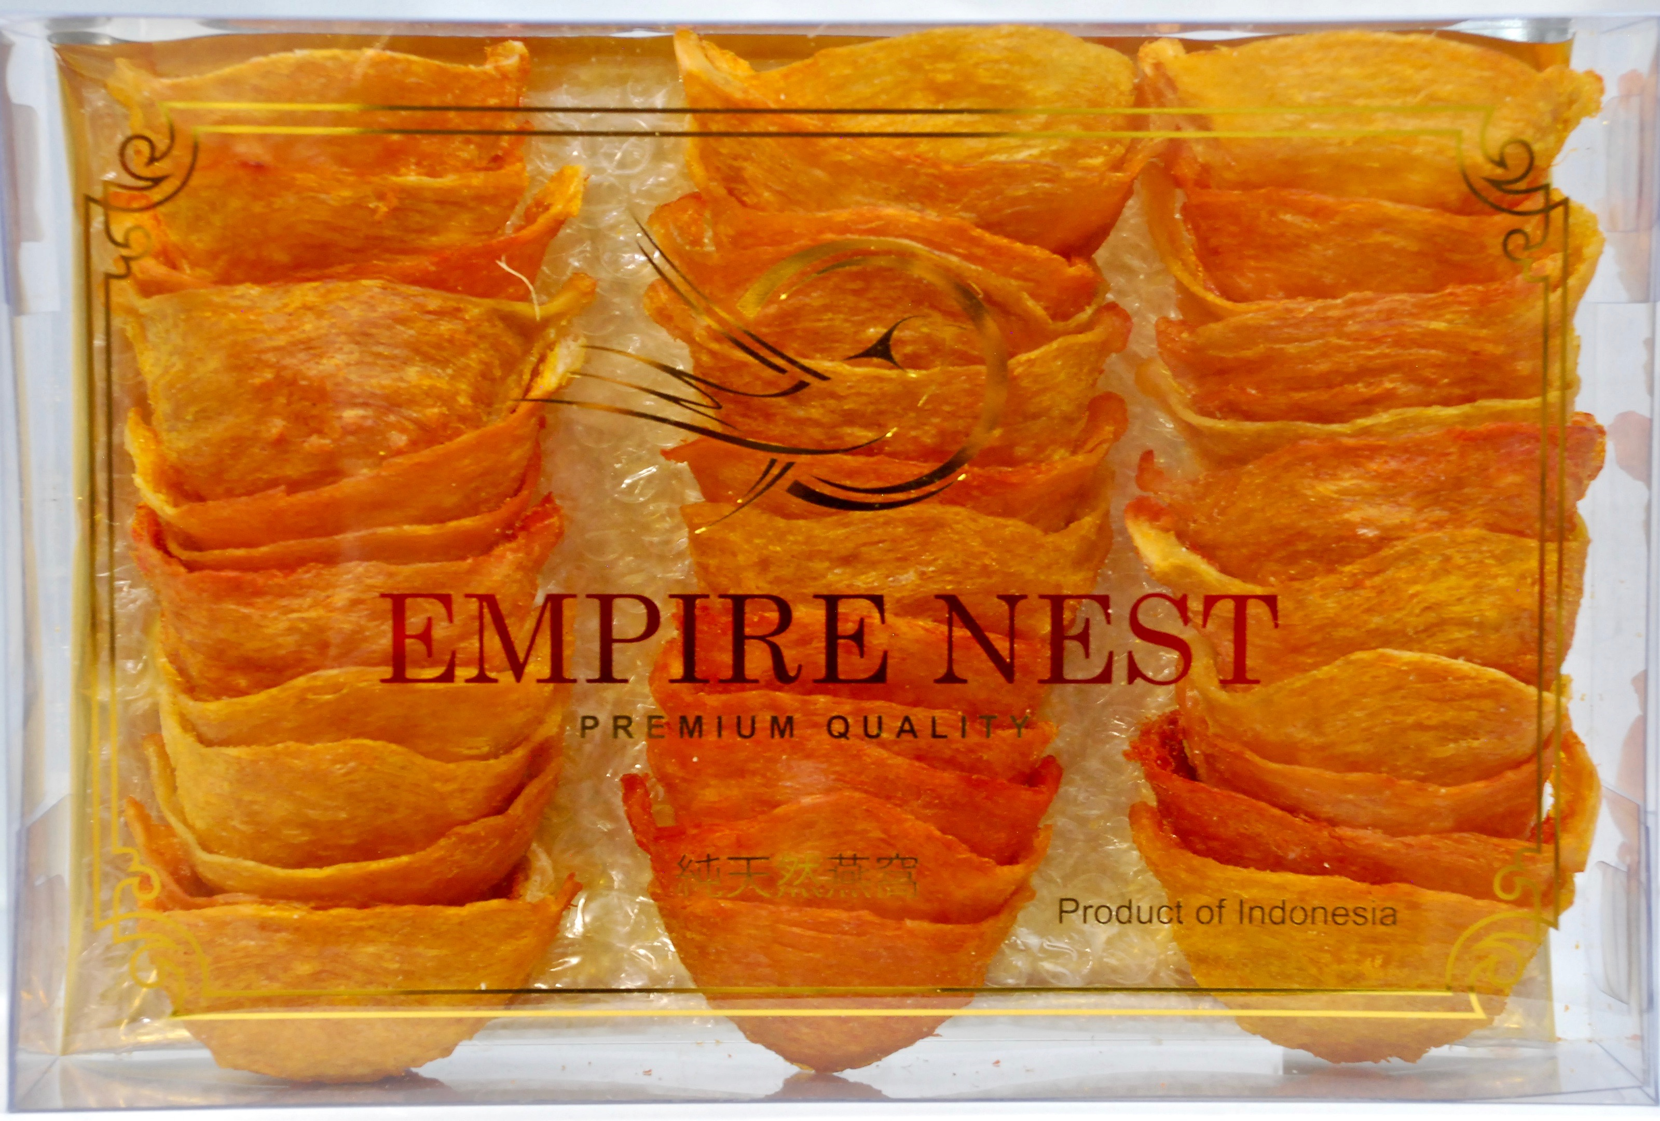

250 grams Super premium Genuine Orange Nest 5A



250 grams Super premium Genuine Orange Nest A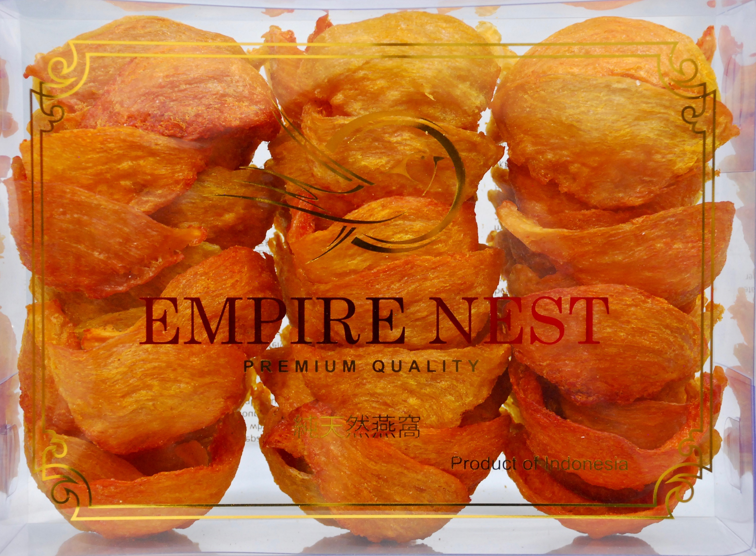

250 grams Super premium Genuine Orange Nest AA



500 grams Super premium Genuine Orange Nest AAAA

